

Football Operator and Optical Soccer Engine (FOOSE)
Initial Project and Group Identification
Nathaniel Enos
Patrick Fenelon
Skyler Goodell
Nicholas Phillips

Senior Design Fall 2012
Executive Summary
IBM’s Watson and Deep Blue computers share the distinction of being the first to beat humans at two of their own games, Jeopardy and chess, respectively. They also share the qualities of being the size of a house and costing a fortune. The price of a digital chess grandmaster has come down since Deep Blue’s historic victory, and we can expect the same for Watson. Yet, there is another sport which requires the data synthesis of answering general-knowledge questions, and the sheer processing power of solving chess. In that sport, a computer which can beat a human affordably has not yet been created.
That sport, of course, is foosball.
Long a favorite of arcades and game rooms, foosball, also known as table soccer, is basically a constrained form of regular soccer. Rows of small armless figures are affixed to metal poles which span the width of the field, which are allowed to rotate freely, thereby enabling the figures to kick a small plastic soccer ball. The object of the game is, as in regular soccer, to score by kicking the ball into the opponent’s goal.
The main goal of the FOOSE project is to create a system which will combine advanced optical tracking, artificial intelligence, control systems, and a foosball table in order to provide a challenging tabletop soccer simulation experience for one or two human players.
Objectives of the FOOSE project are to:
- Be able to process the table state in real time, and react quickly
- Take up only slightly more room than a foosball table would anyway
- Achieve construction within a reasonable budget
- Like its progenitor Watson, beat an average human

FOOSE itself will consist of optical sensors and, potentially, other types of sensors to monitor the state of the foosball table. This information will be fed into a processing unit, which will interpret the data coming from the sensors, decide the appropriate response using artificial intelligence, and digest the response into control data which can be fed to controllers and actuators, realizing the AI’s response, and once more changing the table state. This would continue until the player shuts off the table, or a predetermined goal limit has been reached.

Project Specifications and Requirements
Sensors
Camera
- Camera will operate at a minimum of 30 Frames per Second with a resolution of 960x720.
- Camera will be positioned between 3 – 5 feet above the table surface. The Camera will be oriented facing directly down parallel to the table.
- The Camera Field of View will extend a minimum of 3 inches over the sides of the table to ensure constant view of the game ball.
- Camera latency 160 milliseconds between recognition and actuator output
Laser Range Finders
- Range finder grid will be able to detect a ball within a 2x2 inch grid
- Ranger finders will be placed with at least 5mm clearance below foosball players
- The grid will consist of one of either 2 sweeping range finders or an array of 25 lasers
Encoders and Position Sensors
- 8 Quad Encoders or similar sensors will be used to detect the position of the game poles
- 4 Quad Encoders or similar sensors will be used to detect the rotation of the AI game poles
Actuators/Controls
Lateral Motors
- Move between the extreme ranges of motion within 0.25 seconds.
- 4 Motors used, 1 on each non-user game pole, will control the motion of the game pieces.
- 2 tactile sensors will be places on each end of each game pole to limit the movement of the lateral game pieces. This will reduce damage to the actuator system.
Rotational Motors
- Be able to hit the ball with approximately the same amount of force as a moderate human hit. This quantity will be researched.
- 4 Motors used, 1 on each AI game pole, will control the rotation of the game pieces
Control System
- A linear control system will oversee movement to ensure that motion is swift and controlled. A tight PID loop or similar algorithm will be used to create this.
- Two PCB boards will be fabricated to aggregate sensor input and control actuator output. This will connect to a central CPU that will run the AI and Ball Detection Algorithms.
Table State Interpreter
- The table state interpretation system will create a virtual version of the field containing information about the current ball position, ball velocity, foosball player position and foosball player rotation, within a degree of error that will be evaluated through testing
General AI
- There are a number of possible algorithms that could be used to control the AI opponent on our foosball table. Descriptions follow for each potential method:
  - Greedy AI
    - An AI strategy that focuses solely on placing the opponent’s foosball players in front of the ball. No computations are made to direct the ball anywhere besides forward.
  - Sophisticated Strategy AI
    - This version of the AI will attempt to control and navigate the ball along a specific path to the goal. Specifically it will try to ‘fake out’ and navigate around the human player.

Block Diagrams

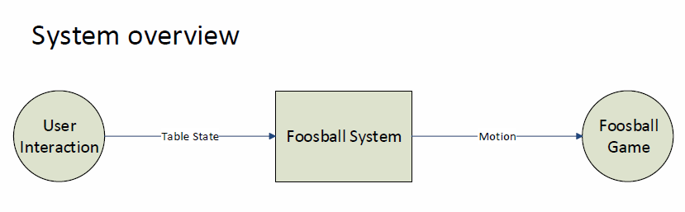

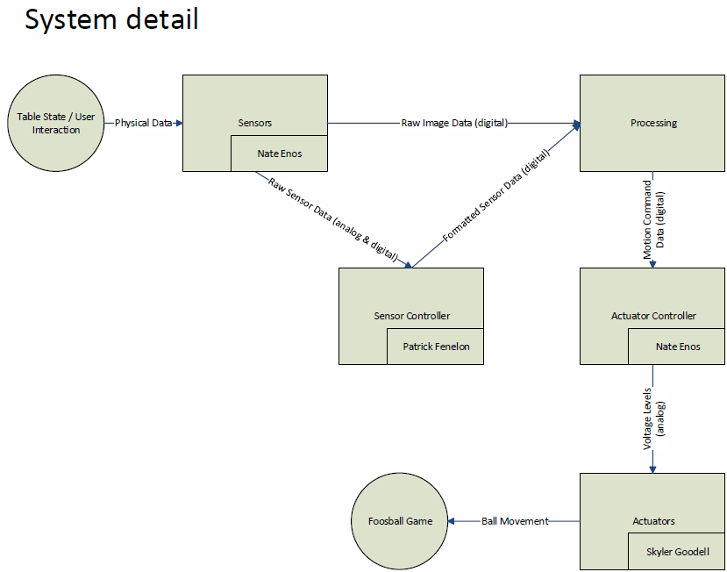
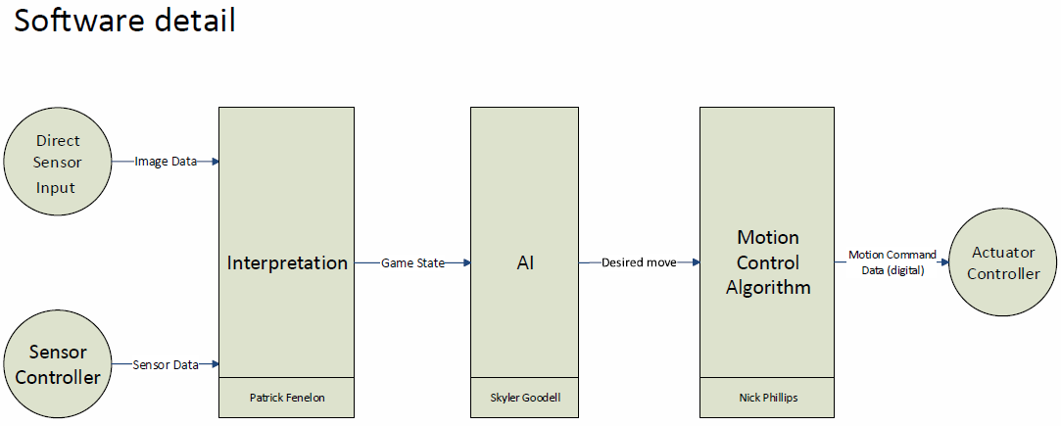

Project Budget and Financing

Components | Quantity | Cost per Unit (dollars) | Total Cost of Component (dollars)
Foosball Table | 1 | 100 | 100
Encoders/Sensors | 12 | 6 | 72
Webcam | 1 | 60 | 60
Main Processor | 1 | 100 | 100
Sensor Controller | 1 | 50 | 50
Actuators/Motors | 8 | 40 | 320
Actuator Controllers | 2 | 40 | 80
Mounting Hardware Set | 1 | 200 | 200
Total |  |  | 982

*Note: additional charges may come with adding a laser range finding grid to the design, this decision has yet to be made.

To finance this project we plan to apply for the SoarTech funding opportunity which consists of a $1000 grant. This grant is estimated to cover the entire cost of the project. In the absence of this grant, the members of our group will split the cost of the project into equal parts.

Project Milestones
Milestone Name | Expected Date |  | Component | Status
Setup 1 | 10/10/2012 |  | Foosball Table | Acquired
Research 1 | 10/20/2012 |  | Sensors | Investigation Begun
 |  |  | Interpretation Software | Prototyping started
 |  |  | Actuators | Investigation Begun
Research 2 | 11/1/2012 |  | Sensors | Prototype visual sensor
 |  |  | Actuator Controller | Initial Design
 |  |  | Interpretation Software | Prototype visual interpretation
Research 3 | 11/15/2012 |  | Sensors | Investigate other sensors
 |  |  | AI Software | Initial Research
 |  |  | Motion Control Algorithm | Initial Research
Research 4 | 12/20/2012 |  | Sensors | Prototype other sensors
 |  |  | Sensor Controller | Initial Design
 |  |  | Actuator Controller | Prototype design
 |  |  | Interpretation Software | Gives input to AI
 |  |  | AI Software | Working simulations
 |  |  | Motion Control Algorithm | Working PID loop
 |  |  | Actuators | Physical Design complete
Setup 2 | 1/30/2013 |  | Foosball Table | Physical addons started
 |  |  | Sensor Controller | First PCB ordered
 |  |  | Actuator Controller | First PCB ordered
 |  |  | Actuators | Physical setup started
Setup 3 | 2/15/2013 |  | Foosball Table | Physical addons working
 |  |  | Sensors | Setup on table
 |  |  | Sensor Controller | First PCB acquired
 |  |  | Actuator Controller | First PCB acquired
 |  |  | Interpretation Software | Prototype code
 |  |  | Motion Control Algorithm | Prototype code
 |  |  | Actuators | Physical Setup complete
Setup 4 | 3/1/2013 |  | Foosball Table | Physical addons complete
 |  |  | Sensors | Setup on table
 |  |  | Sensor Controller | PCB Working
 |  |  | Actuator Controller | PCB Working
 |  |  | Interpretation Software | Revision started
 |  |  | AI Software | Revision started
 |  |  | Motion Control Algorithm | Revision started
Software 1 | 3/15/2013 |  | Interpretation Software | Prototype working
 |  |  | AI Software | Prototype working
 |  |  | Motion Control Algorithm | Prototype working
Software 2 | 4/1/2013 |  | Interpretation Software | Refinement complete
 |  |  | AI Software | Refinement complete

Required
Expected

